<https://www.kaggle.com/datasets/ludehsar/apple-disease-dataset?utm_source=chatgpt.com>

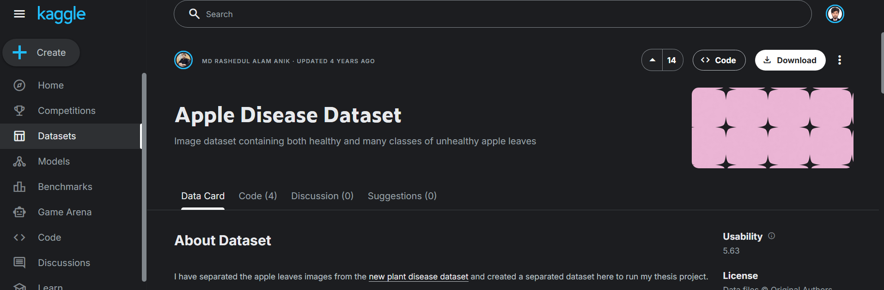

<https://www.scidb.cn/en/detail?dataSetId=0e1f57004db842f99668d82183afd578&utm_source=chatgpt.com>

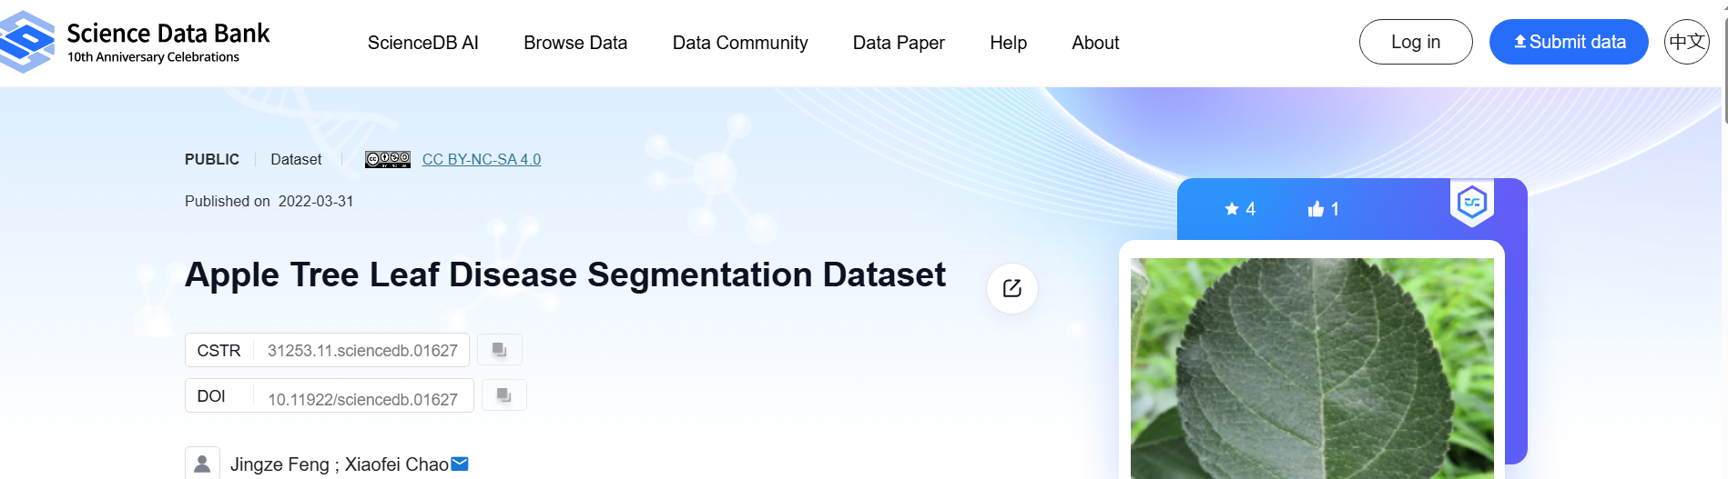

<https://data.mendeley.com/datasets/9m2dcb5mmr/3?utm_source=chatgpt.com>

<https://www.kaggle.com/datasets/amitra19/annotated-apple-leaf-disease-dataset-mask-rcnn?utm_source=chatgpt.com>

